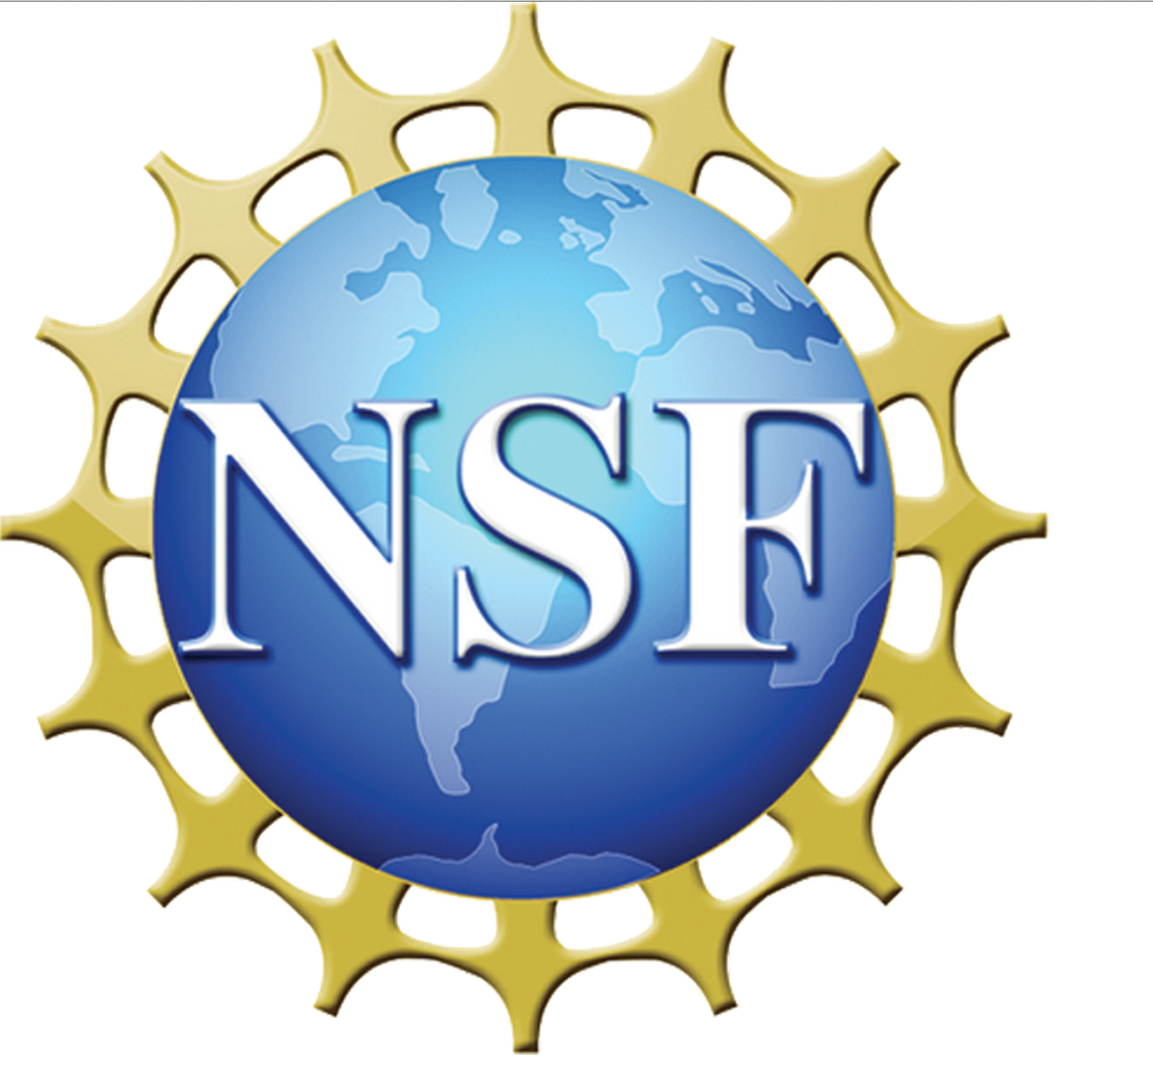
Advancing Data-Intensive Research in Education
Waterview Conference Center
Arlington, VA
May 31st - June 2nd, 2015

Name | Last | Email | Affiliation
Elizabeth | Albro | Elizabeth.albro@ed.gov | Institute of Education Sciences
Peter | Arzberger | parzberg@nsf.gov | NSF
Ryan | Baker | baker2@tc.columbia.edu | Teachers College Columbia University
Brenda | Bannan | bbannan@gmu.edu | George Mason University
Lida | Beninson | lidbenin@nsf.gov | AAAS
Matthew | Berland | mberland@wisc.edu | Univ. of Wisconsin–Madison
Andy | Bernat | andy@bernat.net | CRA
Marie | Bienkowski | marie.bienkowski@sri.com | SRI International
Gautam | Biswas | gautam.biswas@vanderbilt.edu | Vanderbilt University
Lori | Bland | lbland2@gmu.edu | George Mason University
Alex | Bowers | Bowers@exchange.tc.columbia.edu | Teachers College, Columbia University
Thomas | Brock | thomas.brock@ed.gov | Institute of Education Sciences
Elizabeth | Buchanan | buchanane@uwstout.edu | University of Wisconsin-Stout
Elizabeth | Burrows | eburrows@nsf.gov | AAAS Fellow at NSF
Al | Byer | National Science Teachers Association | abyers@nsta.org
John | Cherniavsky | jchernia@nsf.gov | National Science Foundation
Jere | Confrey | jere_confrey@ncsu.edu | North Carolina State University
Sandra | Corbett | scorbett@cra.org | CRA
Richard | Culatta | richard.culatta@ed.gov | U.S. Department of Education
Arlene | de Strulle | adestrul@nsf.gov | NSF
Chris | Dede | chris_dede@harvard.edu | Harvard University
Edward | Dieterle | ed.dieterle@summitllc.us | Summit Consulting
Michelle | Dunn | dunnm3@mail.nih.gov | National Institutes of Health
Earnestine | Easter | epsalmon@nsf.gov | National Science Foundation
Sloane | Finbarr | fsloane@nsf.gov | National Science Foundation
Dexter | Fletcher | fletcher@ida.org | Institute for Defense Analyses
Ari | Gesher | regs@palantir.com | Palantir Technlogoies
Rick | Gilmore | rick@databrary.org | Databrary.org
Jay | Goodwin | jtgoodwi@nsf.gov | NSF/AAAS Science & Technology Policy Fellow
Edith | Gummer | egummer@kauffman.org | Ewing Marion Kauffman Foundation
Patricia | Hammar | phammar@pkhenterprises.com | PKH Enterprises
Natalie | Harr | nharr@nsf.gov | NSF
Erin | Higgins | Erin.Higgins@ed.gov | Institute of Education Sciences
Andrew | Ho | andrew_ho@gse.harvard.edu | Harvard Graduate School of Educatoin
Sabrina | Jacob | sjacob@cra.org | Computing Research Association
Aditya | Johri | ajohri3@gmu.edu | George Mason University
Shaun | Kellogg | sbkellog@ncsu.edu | North Carolina State University
Anthony | Kelly | akelly@nsf.gov | NSF
Henry | Kelly | henry.kelly@hq.doe.gov | Dept of Energy
Eric | Klopfer | klopfer@mit.edu | MIT
Ken | Koedinger | koedinger@cmu.edu | Carnegie Mellon University
Gül | Kremer | gkremer@nsf.gov | NSF
Ruth | Krumhansl | rkrumhansl@edc.org | Oceans of Data Institute, Education Development Center, Inc
Vijay | Kumar | vkumar@mit.edu | MIT
Christopher | Laubenthal | claubenthal@kauffman.org | Ewing Marion Kauffman Foundation
Kevin | Lee | kelee@nsf.gov | National Science Foundation
Soo-siang | Lim | slim@nsf.gov | NSF
Deborah | Lockhart | dlockhar@nsf.gov | National Science Foundation
Britt | Lundgren | lundgren@astro.wisc.edu | University of Wisconsin - Madison
Krishna | Madhavan | cm@purdue.edu | Purdue University
Taylor | Martin | htmartin@nsf.gov | NSF
Amanda | Mason-Singh | amanda.mason-singh@hobsons.com | Hobsons
Dave | Micklos | micklos@cshl.edu | DNA Learning Center, Cold Spring Harbor Laboratory
Steven | Miller | steven.miller@us.ibm.com | IBM
Piotr | Mitros | pmitros@edx.org | edX
Nishal | Mohan | nmohan@nsf.gov | NSF
Roger | Nozaki | roger.nozaki@ed.gov | US Department of Education
Diana | Oblinger | doblinger@educause.edu | EDUCAUSE
Una-May | OReilly | unamay@mit.edu | MIT
Zach | Pardos | zp@berkeley.edu | University of California, Berkeley
Jaimin | Patel | jpatel@tuvalabs.com | Tuva Labs
Yuri | Podpaly | ypodpaly@nsf.gov | NSF - AAAS
Renata | Rawlings-Goss | rrawling@nsf.gov | NSF - CISE OAD
Damian | Saccocio | Damian@edcast.com | EdCast
Val | Shute | vshute@fsu.edu | Florida State University
George | Siemens | gsiemens@gmail.com | LINK Lab, UT Arlington
Susan | Singer | srsinger@nsf.gov | NSF
Ellen | Wagner | ellen.wagner@parframework.org | PAR Framework
Shuangbao | Wang | paul@nisti.org | University of Maryland
Craig | Wiggins | craig.wiggins.ctr@adlnet.gov | Advanced Distributed Learning Initiative
Marcelo | Worsley | worsley@usc.edu | University of Southern California
Helen | Wright | hwright@cra.org | CRA
David | Yaskin | david.yaskin@hobsons.com | Hobsons

